|  |  |
| --- | --- |
| |  | | --- | | GAP Claims  SPFx Deployment Guide | |

Contents

GAPClaims 1

SPFx Deployment Guide 1

1. Document information 4

2. Purpose 5

3. Setup Development Environment 5

3.1 Download and Install Dependencies for SPFx Development Environment 5

4. GAPClaims Webpart Deployment 6

4.1 Download Source Code 6

4.2 Install Dependency Files and Solution Build 6

4.3 Deploy Package in SharePoint App Catalog 8

4.4 Create Page and Add Webpart 11

5. Inject CSS Application Customizer Deployment 13

5.1 Download Source Code 13

5.2 Install Dependency Files and Solution Build 14

5.3 Deploy package in SharePoint App Catalog 15

5.4 Create CSS File and Add in Site Asset 19

# Document information

**History**

|  |  |  |  |
| --- | --- | --- | --- |
| **Date** | **Version** | **Revision Author(s)** | **Notes** |
| 16/08/2022 | 1.0 | Komal Singh |  |
|  |  |  |  |
|  |  |  |  |
|  |  |  |  |
|  |  |  |  |

**Reviewers and Approvers**

|  |  |  |  |
| --- | --- | --- | --- |
| **Date** | **Version** | **Reviewer/Approver (role)** | **Note** *(State if document was reviewed or approved. Add additional notes, and* ***Screenshot of Approval Email****)* |
|  |  |  |  |
|  |  |  |  |
|  |  |  |  |
|  |  |  |  |
|  |  |  |  |

# Purpose

The purpose of the Deployment Guide document is to provide the procedures which need to be followed from downloading source code to add the webpart and extension in page.

# Setup Development Environment

## Download and Install Dependencies for SPFx Development Environment

**Development Prerequisites**

1. Node JS Version – 14
2. Gulp version – 4.0.2
3. Yeoman version – 4.2.0
4. SharePoint Framework version – 1.12.1
5. Visual Studio Code

**Step 1**: Go to “<https://nodejs.org/en/>”. Download and install the 14 version of **Node JS 14**



**Step 2**: Open command Prompt from the machine.

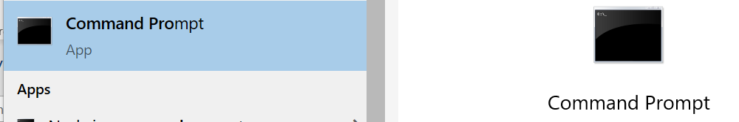

**Step 3**: Run the below command to install the Gulp, Yeoman and SharePoint Framework in a machine.

*npm install gulp-cli yo @microsoft/generator-sharepoint –global*

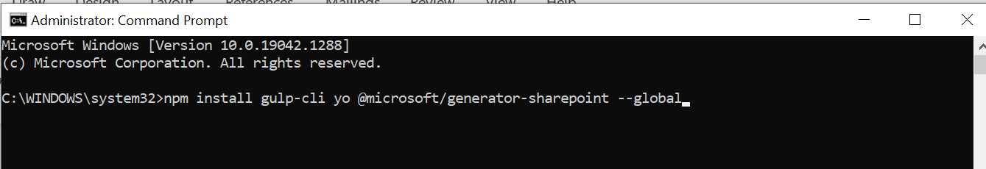

**Step 4**: Install the Visual Studio Code in “<https://code.visualstudio.com/>” link.

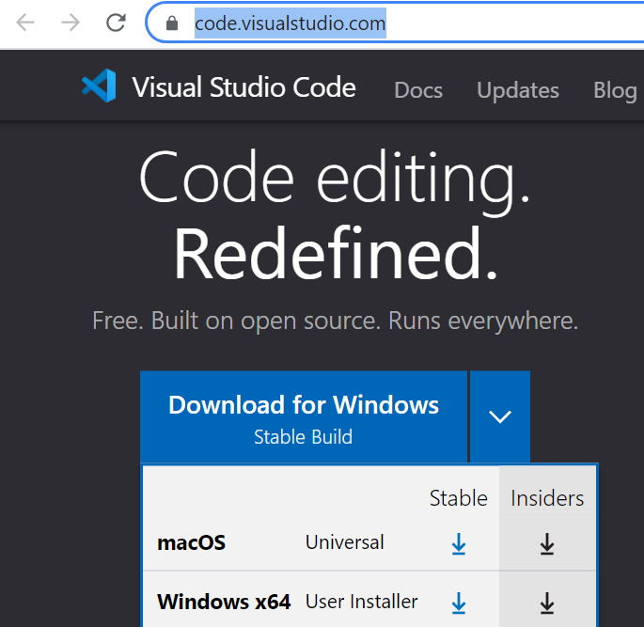

# Claim Counsel Survey Webpart Deployment

## Download Source Code

**Step 1**: Click this ”[GAP Claims- Code Base - All Documents (sharepoint.com)](https://zurichinsurancenam.sharepoint.com/sites/CLAIMCOUNSEL/SiteAssets/Forms/AllItems.aspx?id=%2Fsites%2FCLAIMCOUNSEL%2FSiteAssets%2FCode%20Base%2FQA%2FSurvey%20Forms&viewid=5f4f4850%2De0a6%2D4c5e%2Db4f8%2D9d879eeff56d) ” URL and download the GapClaims-ZIP file from the path

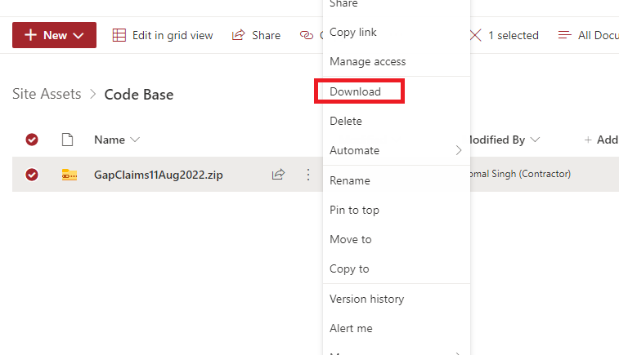

**Step 2**: Download the latest updated solution Zip file and extract to the development machine location.

## Install Dependency Files and Solution Build

**Step 3**: Open command Prompt from the machine.



**Step 4**: Copy the webpart solution folder path to run it in the command prompt.

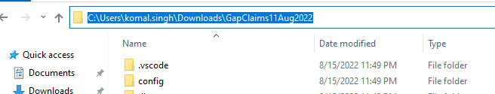

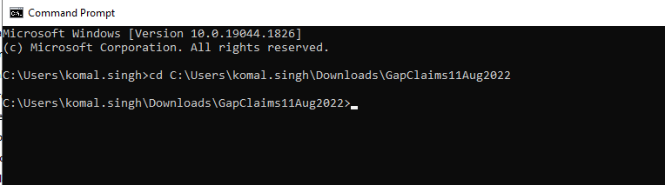

**Step 5**: Run “npm install” command in the prompt to install all the dependency packages to the solution.

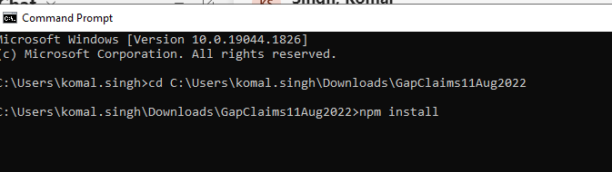

**Step 6**: Run “gulp build” command to build the solution and make sure that no error is been detected during this process in Problem window in terminal.

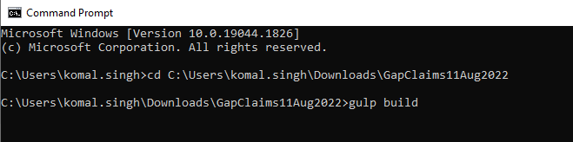

**Step 7**: Run “gulp bundle --ship” command to bundle the solution.

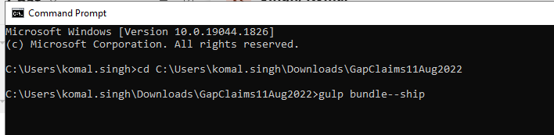

**Step 8**: Run “gulp package-solution --ship” command to package the solution, as a result the SPPKG file will be generated inside sharepoint\solution folder.

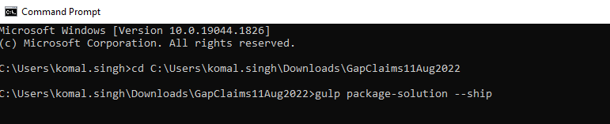

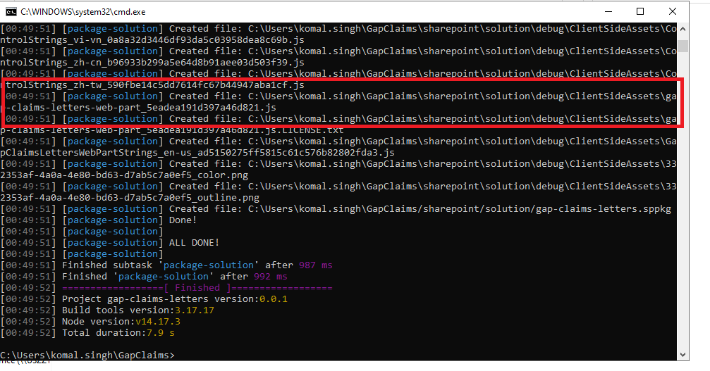

## Deploy Package in SharePoint App Catalog

**Step 9**: Login to SharePoint and click link to go to site

Production Site URL “<https://zurichinsurancenam.sharepoint.com/sites/GAPClaims/AppCatalog/Forms/AllItems.aspx>”

QA Site URL

“<https://zurichinsurancenam.sharepoint.com/sites/GAPClaims_QA/AppCatalog/Forms/AllItems.aspx>”

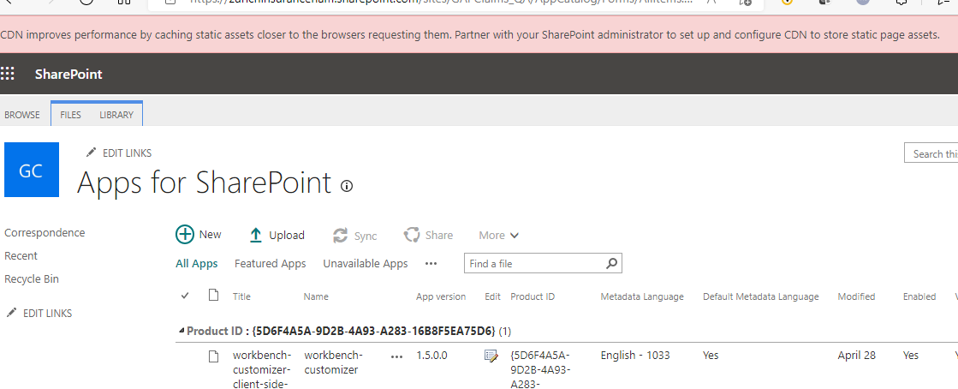

**Step 10**: Click Upload option and select the SPPKG file. Click OK to upload the package in App catalog.

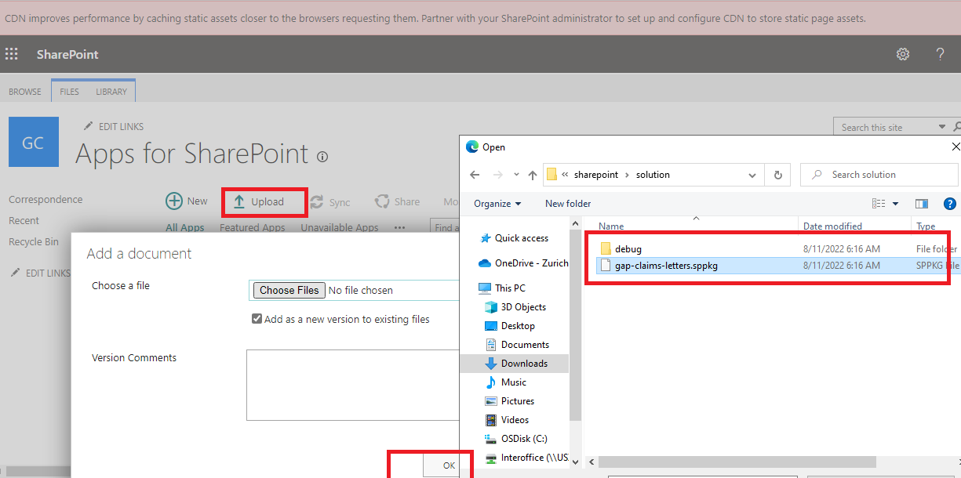

**Step 11**: Click Deploy button the deploy the package in the catalog

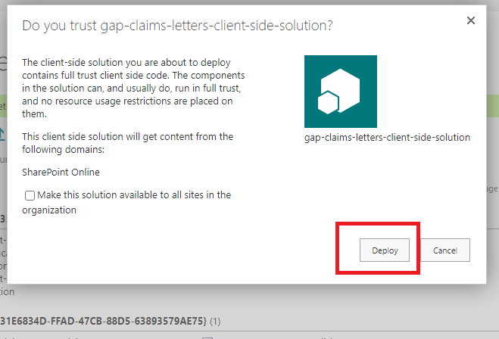

**Step 12**: After deploying make sure that the package has deployed without any error by checking Deployed column “Yes” and App package error message “No errors”.

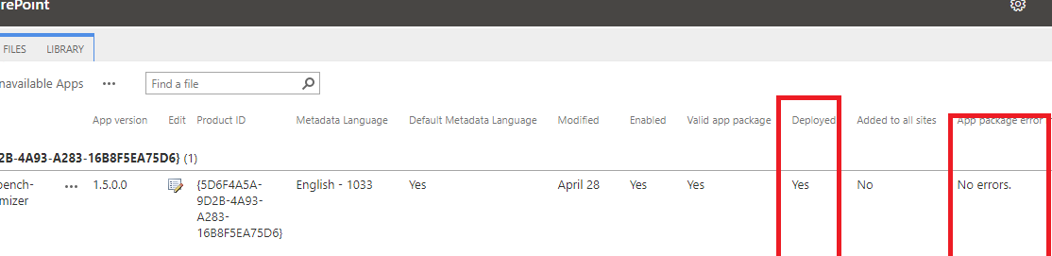

**Step 13**: Click to setting icon on top right corner to select add an app.

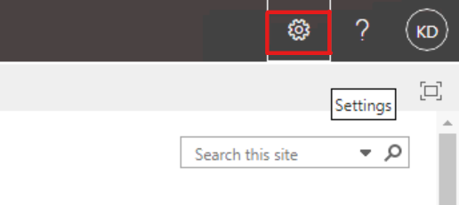

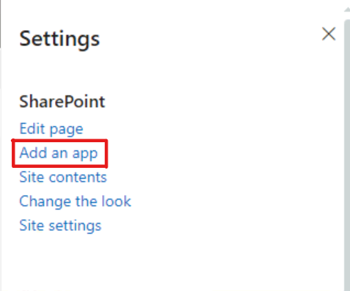

**Step 14**: Find the deployed webpart in your apps page and click on the app to add app to the site.

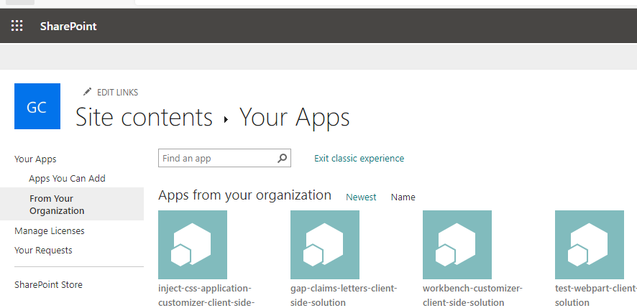

**Step 15**: Make sure that added app is displaying under this site content page

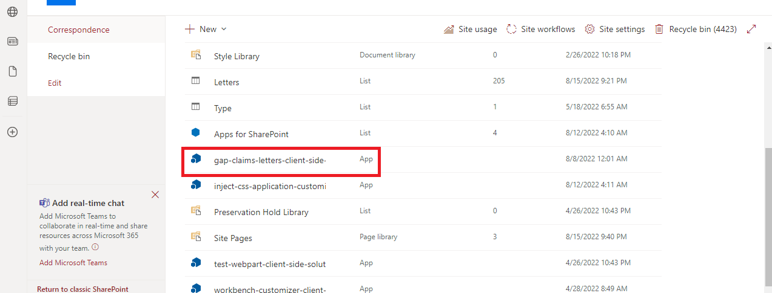

## Create Page and Add Webpart

**Note:** Follow the below Steps only when the new page is created in the SharePoint Site

**Step 16**: Go to below link

Product Site URL - “<https://zurichinsurancenam.sharepoint.com/sites/GAPClaims>“

QA Site URL - “[https://zurichinsurancenam.sharepoint.com/sites/ GAPClaims_QA](https://zurichinsurancenam.sharepoint.com/sites/%20GAPClaims_QA) “

Click New option in top left corner of the site and select page to create a new page.

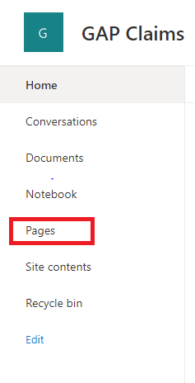

**Step 17**: Add Name of the page in page banner and click publish button.

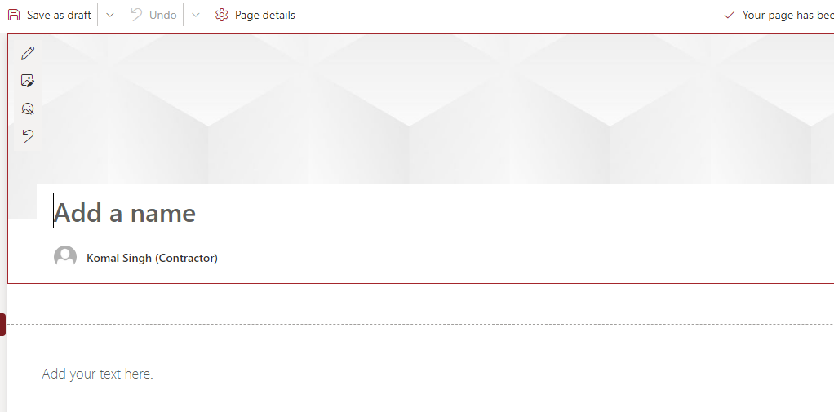

**Step 18**: Edit the page and click section plus icon and select one column layout to define the section layout.

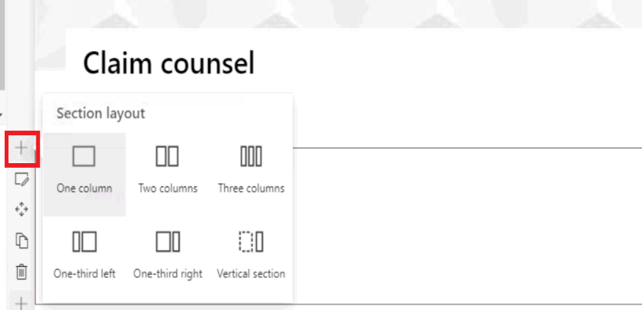

**Step 19**: Click plus icon inside the section. Search and find the added webpart and click to add the webpart in a page.

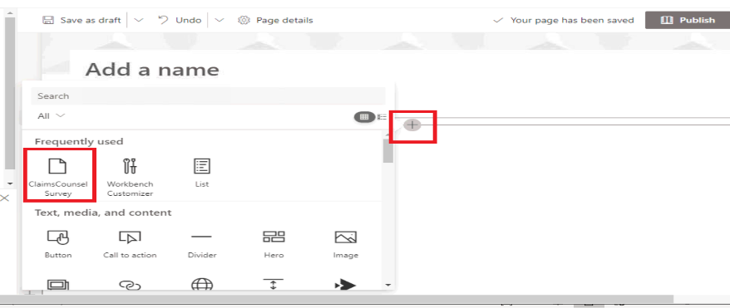

**Step 20**: Click edit icon to give configuration details of the webpart.

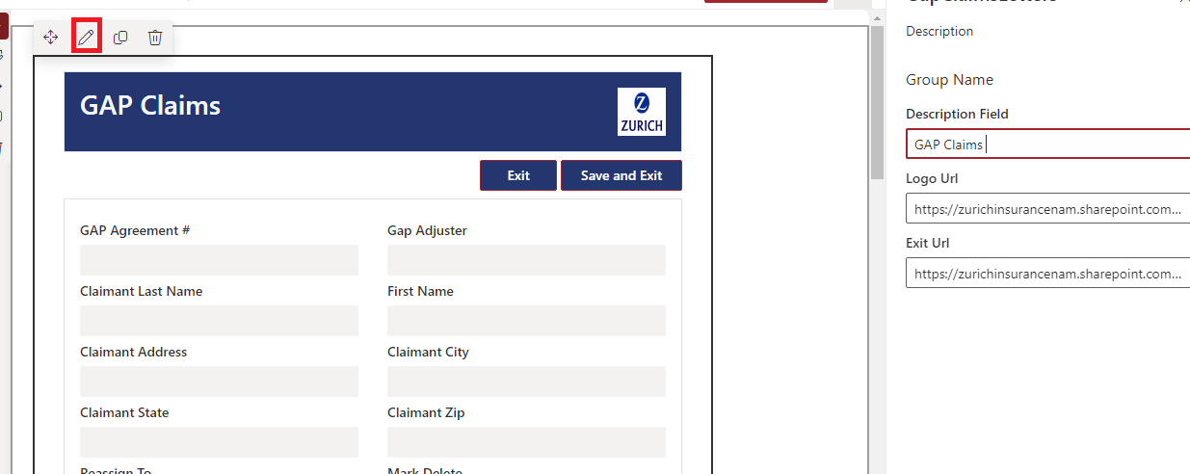

**Step 21**: Provide the Logo uploaded SharePoint path in Logo field and give exit location as default view page in Exit Location control to let the user to navigate to the page after successfully completes the request.

Form Title-Staff Legal Services

**Logo Path**

Production Site URL

[https://zurichinsurancenam.sharepoint.com/sites/GAPClaims /SiteAssets/Images/Zurich Logo.jpg](https://zurichinsurancenam.sharepoint.com/sites/GAPClaims%20/SiteAssets/Images/Zurich%20Logo.jpg)

QA Site URL

[https://zurichinsurancenam.sharepoint.com/sites/GAPClaims _QA/SiteAssets/Images/Zurich Logo.jpg](https://zurichinsurancenam.sharepoint.com/sites/GAPClaims%20_QA/SiteAssets/Images/Zurich%20Logo.jpg)

**Exit Location**

Production Site URL

<https://zurichinsurancenam.sharepoint.com/sites/GAPClaims/SitePages/Correspondence.aspx>

QA Site URL

<https://zurichinsurancenam.sharepoint.com/sites/GAPClaims_QA/SitePages/Correspondence.aspx>

# Inject CSS Application Customizer Deployment

## Download Source Code

**Step 1**: Click “[https://zurichinsurancenam.sharepoint.com/:u:/r/sites/CLAIMCOUNSEL/SiteAssets/Code%20Base/Production/Inject%20CSS/InjectCssApplicationCustomizer_021522.zip?csf=1&web=1](https://zurichinsurancenam.sharepoint.com/:u:/r/sites/CLAIMCOUNSEL/SiteAssets/Code%20Base/Production/Inject%20CSS/InjectCssApplicationCustomizer_021522.zip?csf=1&web=1&isSPOFile=1)” link and download the Inject CSS Solution ZIP file

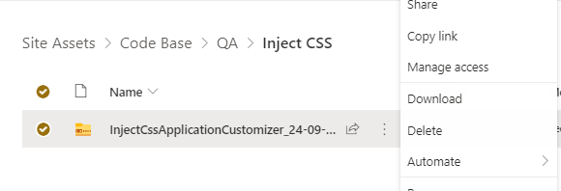

## Install Dependency Files and Solution Build

**Step 2**: Open command Prompt from the machine.



**Step 3**: Copy the Extension solution folder path to run it in the command prompt.

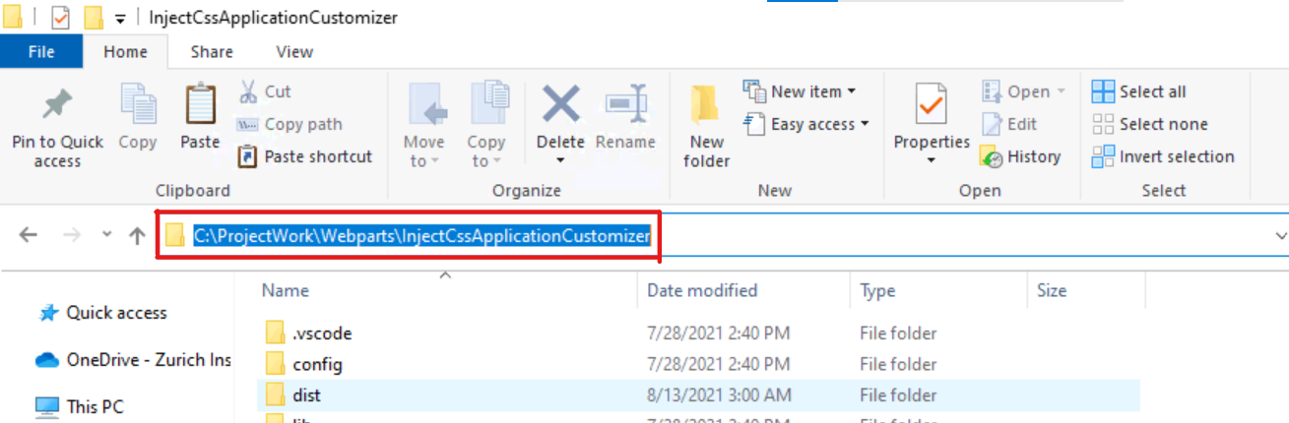

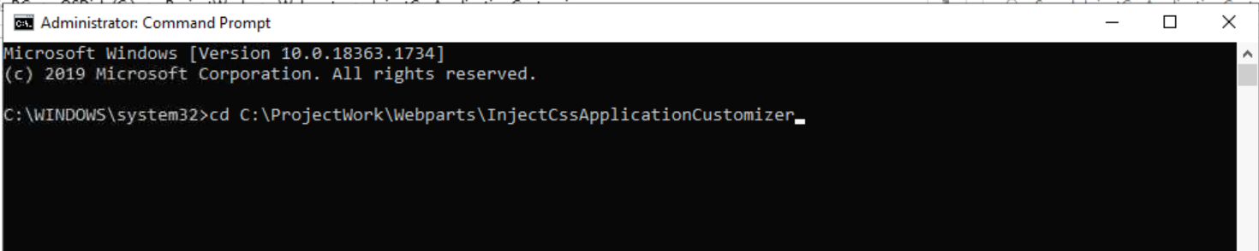

**Step 4**: Run “npm install” command in the prompt to install all the dependency packages to the solution.

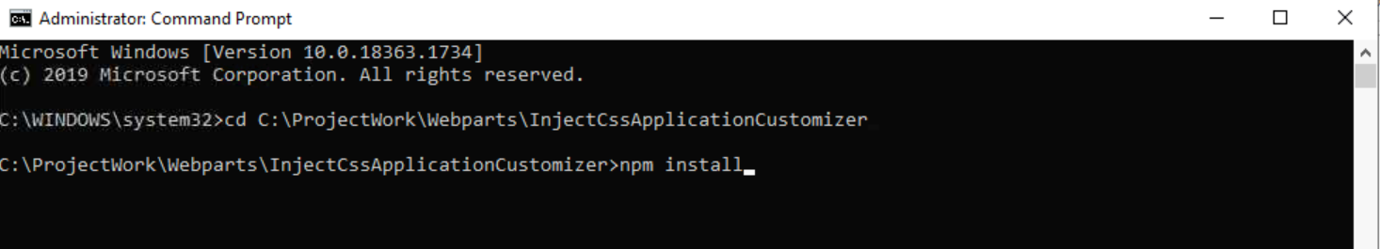

**Step 5**: Run “gulp build” command to build the solution and make sure that no error is been detected during this process in Problem window in terminal.

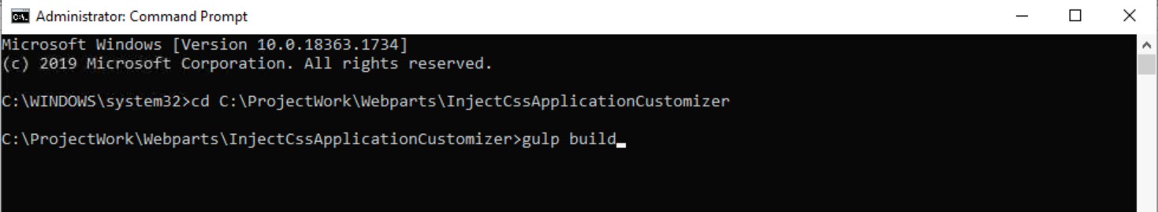

**Step 6**: Run “gulp bundle --ship” command to bundle the solution.

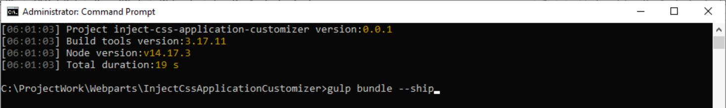

**Step 7**: Run “gulp package-solution --ship” command to package the solution, as a result the SPPKG file will be generated inside sharepoint\solution folder.

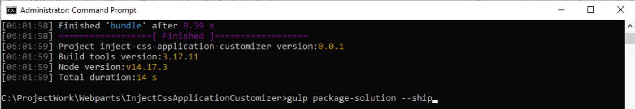

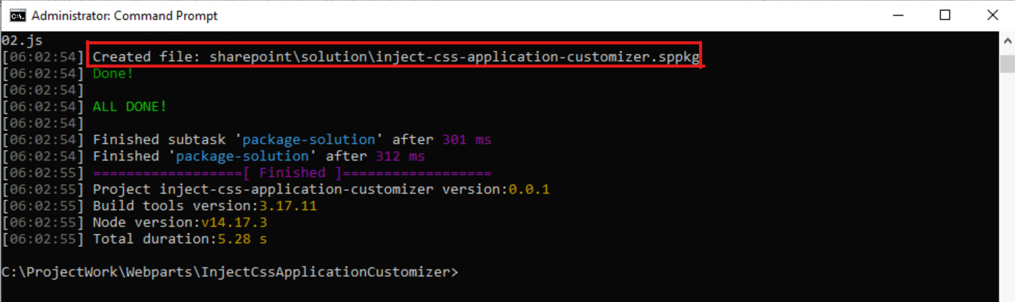

## Deploy package in SharePoint App Catalog

**Step 8**: Login to SharePoint and go to “[https://zurichinsurancenam.sharepoint.com/sites/GAPClaims/AppCatalog/Forms/AllItems.aspx”](https://zurichinsurancenam.sharepoint.com/sites/GAPClaims/AppCatalog/Forms/AllItems.aspx) site.

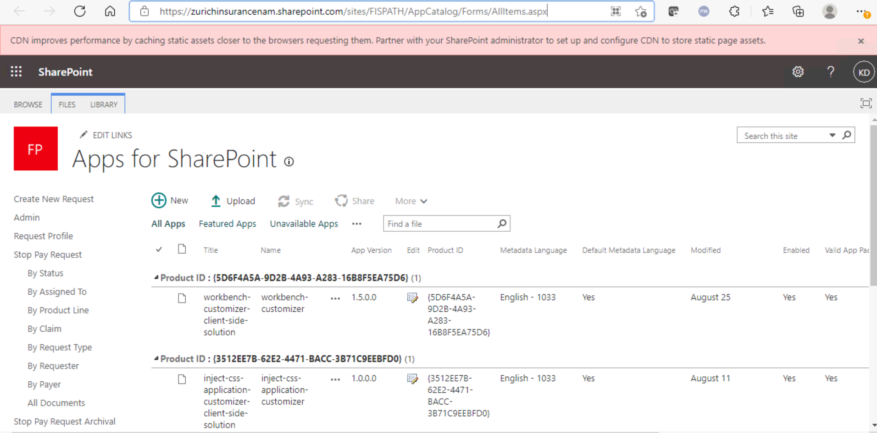

**Step 9**: Click Upload option and select the SPPKG file. Click OK to upload the package in App catalog.

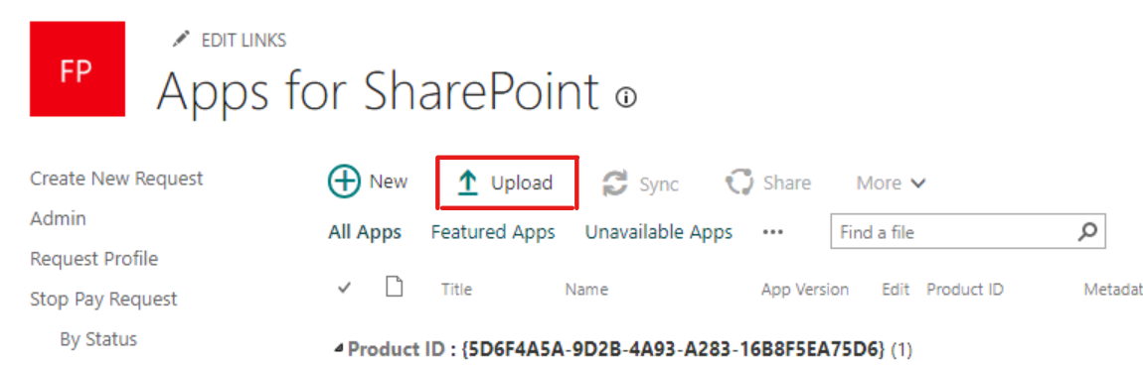

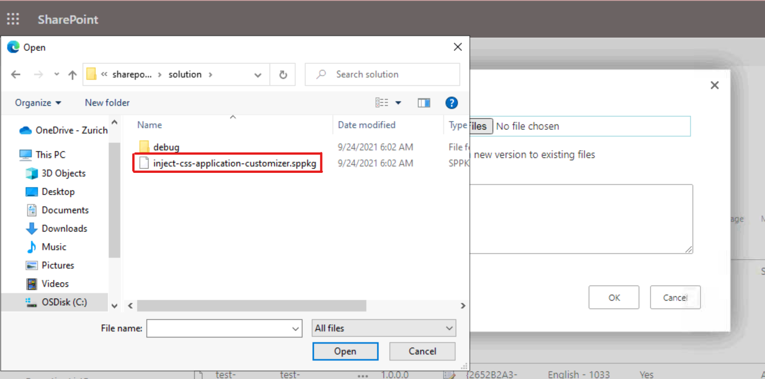

**Step 10**: Click Deploy button the deploy the package in the catalog

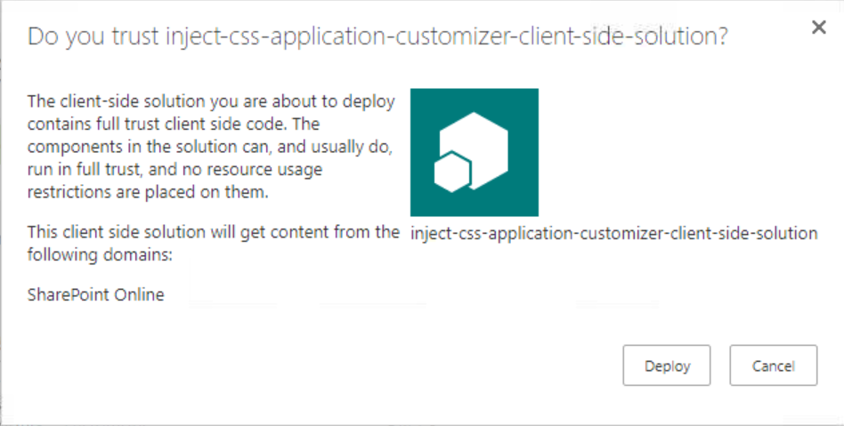

**Step 11**: After deploying make sure that the package has deployed without any error by checking Deployed column “Yes” and App package error message “No errors”.

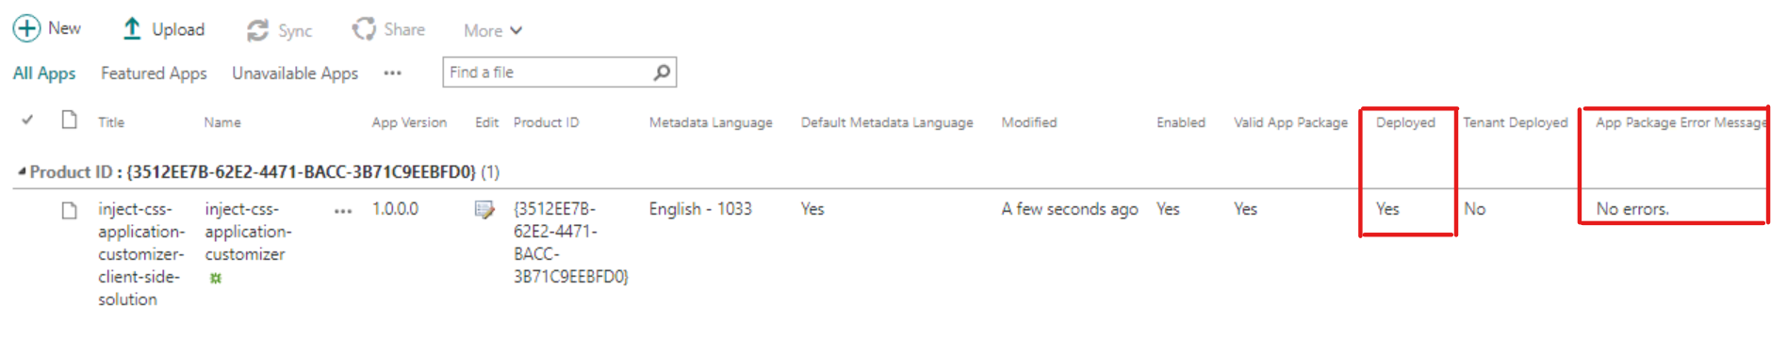

**Step 12**: Click to setting icon on top right corner to select add an app.





**Step 13**: Find the deployed extension in your apps page and click on the app to add app to the site.

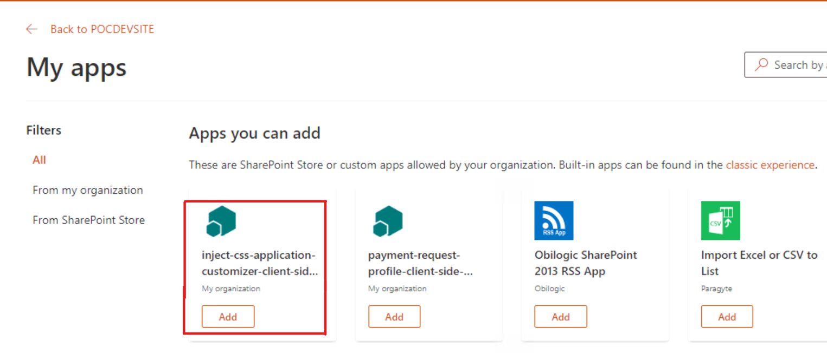

**Step 14**: Make sure that added app is displaying under this site content page

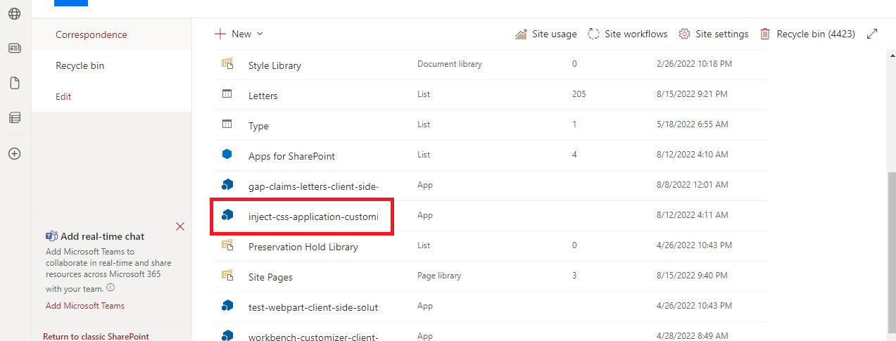

## Create CSS File and Add in Site Asset

**Step 15**: Go to “https://zurichinsurancenam.sharepoint.com/sites/GAPClaims/_layouts/15/viewlsts.aspx?view=14”

Click Site Asset document library from site content.

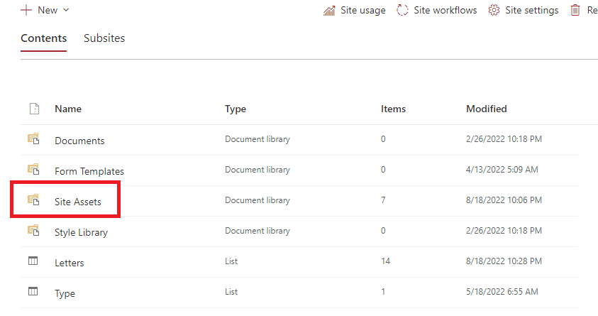

**Step 26**: Click on the Style Sheet folder to add the CSS to apply to sites.

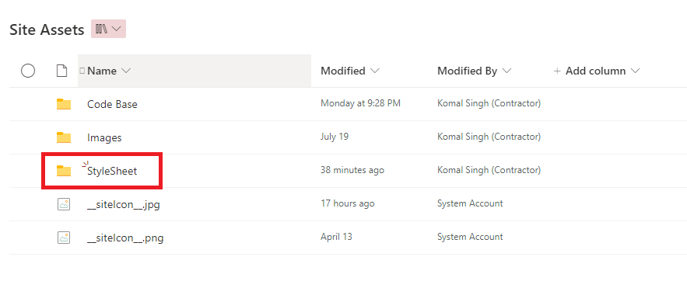

**Step 17**: Click upload link and select file option from the dropdown.

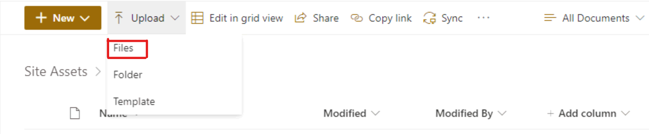

**Step 18**: Select the downloaded CSS file from local machine to upload it in SharePoint Site Asset.

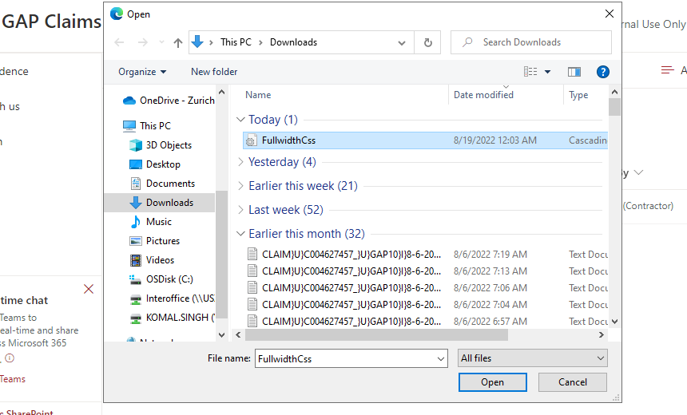

**Step 19**: uploaded file should be present under the Style Sheet folder to refer in the extension.

